Investigation of the Contact Behaviour of a Tyre for Non-Steady Maneouvers by Means of Frustated Total Reflection

Tobias Hellberg¹, Martin Meywerk¹
¹ Automotive and Powertrain Engineering Institute , Department of Mechanical Engineering
Helmut-Schmidt-University, University of the Federal Armed Forces Hamburg

Key Words: Contact, Tyre, Non-Steady Maneouver, Frustated Total Reflection.

Understanding the contact phenomena in the contact area of a tyre and the road different means of investigation can be used. For standing or slowly rolling tyres without large torques, pressure sensitive films can be used. For higher velocities or torques, the use of a glas or plexiglas driving surfaces can be used, to obtain insight to the contact behaviour. The pure view to the contact patch through the glas driving surface can be improved by benefit from the frustrated total reflection [1,2].
In this talk we will present results from non-steady tyre-driving-surface-contact investigated by a half-vehicle test rig (Fig. 1), where the driving surface is plexiglas and additional light for benefit from frustrated total reflections (Fig. 2) is applied to the front faces of the plexiglas. The maneouver is similar to a racing start (i.e. it is non-steady starting from standstill). The investigation allows insight in the contact patch for this non-steady process.

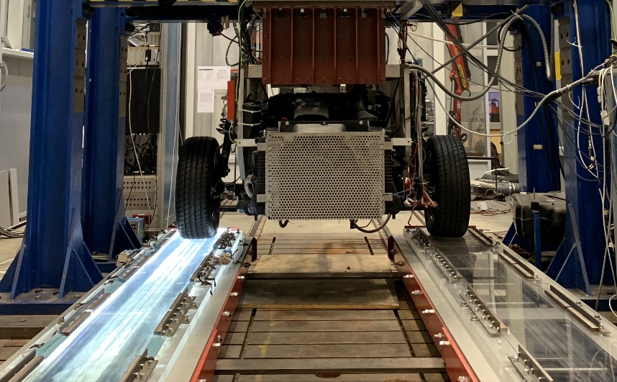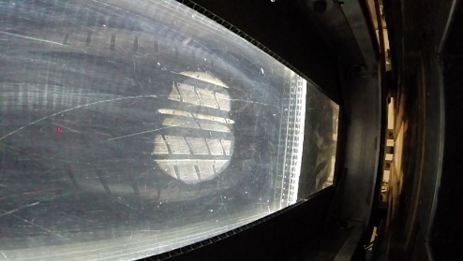
Fig.1.: Test rig for investigation of non-steady maneouvers Fig. 2: FTR-picture contact pactch
REFERENCES
- J. J. Castillo Aguilar, J. A. Cabrera Carrillo, A. J. Guerra Fernández and S. Postigo Pozo: Optimization of an Optical Test Bench for Tire Properties Measurement and Tread Defects Characterization, Sensors, 17, 707, 2017.
- C. R. Gentle: Optical Mapping of Pressures in Tyre Contact Area, Optics and Lasers in Engineering 4, 167-l 76, 1983.

